This homework has two parts! - Be sure to scroll down to find Exercise 2 as well.
Exercise 1.
For each of the examples below
- answer the questions following the sentence
- Provide a diagram of the sentence.

- People with giant trucks and dogs with bandanas both irritate me unreasonably.
  - In this example is “and” coordinating two clauses or two phrases?

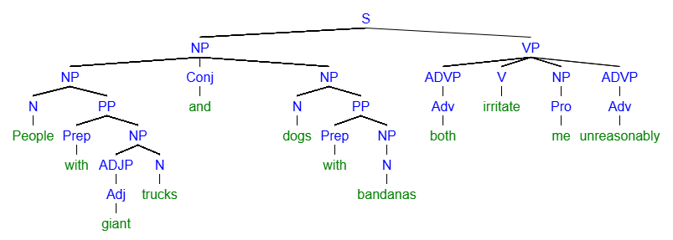
[S [NP [NP [N People] [PP [Prep with] [NP [ADJP [Adj giant]] [N trucks]]]] [Conj and] [NP [N dogs] [PP [Prep with] [NP [N bandanas]]]]] [VP [ADVP [Adv both]] [V irritate] [NP [Pro me]] [ADVP [Adv unreasonably]
- Steve is quite tall even though his mother is short.
  - Is “even though” a coordinating conjunction or a subordinating conjunction?
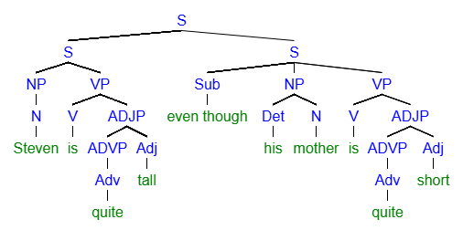

[S [S [NP [N Steven]] [VP [V is] [ADJP [ADVP [Adv quite]] [Adj tall]]]] [S [Sub even though] [NP [Det his] [N mother]] [VP [V is [ADJP [ADVP [Adv quite]] [Adj short]
- When I get tired, I become stupid and act irritably.
  - What type of phrase is being coordinated by “and”?
    - Verb Phrase

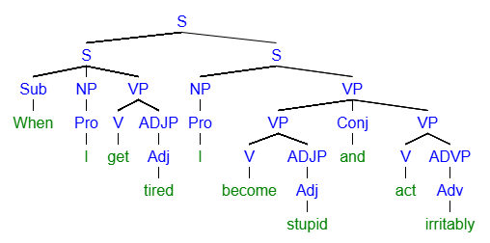
[S [S [Sub When] [NP [Pro I]] [VP [V get] [ADJP [Adj tired]]]] [S [NP [Pro I]] [VP [VP [V become] [ADJP [Adj stupid]]] [Conj and][VP [V act] [ADVP [Adv irritably]
- Penn and Teller are bad comedians, but they seem pretty good at magic.
  - Is “and” connecting two clauses or two phrases?
  - Is “but” connecting two clauses or two phrases?

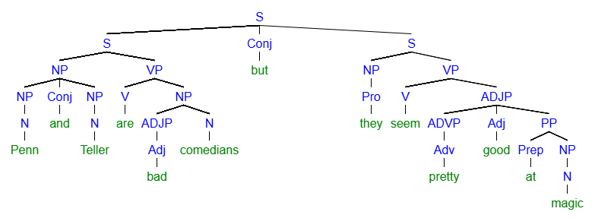
[S [S [NP [NP [N Penn]] [Conj and] [NP [N Teller]]] [VP [V are] [NP [ADJP [Adj bad]] [N comedians]]]] [Conj but] [S [NP [Pro they]] [VP [V seem] [ADJP [ADVP [Adv pretty]] [Adj good] [PP [Prep at] [NP [N magic]
For each of the sentences below, please revise the sentence to follow the most formal prescriptive rules for punctuation.

- Mary never buys fast food, however, she does cook the occasional frozen pizza.
  - Mary never buys fast food. However, she does cook the occasional frozen pizza.
  - Mary never buys fast food; however, she does cook the occasional frozen pizza.
- Although Tommy has read many books he still prefers films.
  - Although Tommy has read many books, he still prefers films.
  - Tommy still prefers films although he has read many books.

- I never knew clouds were made of water, it blew my mind.
  - I never knew clouds were made of water. It blew my mind.
  - I never knew clouds were made of water; it blew my mind.

- I learned to play bass guitar in high school. But I haven’t practiced in decades.
  - I learned to play bass guitar in high school, but I haven’t practiced in decades.
  - I learned to play bass guitar in high school. However, I haven’t practiced in decades.

- I really prefer sandwiches with mayo and pickles, but still enjoy ketchup on my hotdogs.
  - I really prefer sandwiches with mayo and pickles but still enjoy ketchup on my hotdogs.
  - I really prefer sandwiches with mayo and pickles, but I still enjoy ketchup on my hotdogs.

